
By Cabman on 1th February
Overview
Cabman Data

Table of contents
1. Introduction 3
2. Live Overview 4
3. Drivers 5
4. Vehicles 6
5. Shifts 8
5.1 Totals for selected Driver(s) 9
5.2 Totals for selected Vehicle(s) 9
5.3 Shift summary 10
5.4 Payment summary 10
5.5 VAT Summary 11
5.6 Export to PDF and Excel 11

Introduction
This document serves as a complete overview of how to get started with Cabman Data and gain insight into the backend solution for your Cabman MDT in your taxi. The aim is to give you a thorough understanding of the product and how to use it correctly and have a solid administration.
In order to get started with Cabman Data, your Cabman Meter must be installed in the vehicle and you must have been given login details for Cabman Data. The instructions in this document will set you up to view your vehicles, enter your drivers and receive reports of your revenue.
Tab
Live View | An overview of where your vehicles are located.
Drivers | Adding and altering your drivers.
Vehicles | An overview of your vehicles and their details
Shifts | All ended and ongoing shifts are shown here, and the revenue can be calculated.
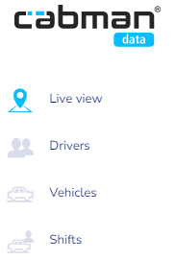
When you open Cabman Data, you will see that the portal has several tabs. These are the following:

In each chapter of this guide you will find information about the different tabs and how to use them. Without further ado, let's get started!

Live Overview
Let's start with the live overview. When you open Cabman Data the first thing you'll see is a live overview of where your vehicles are. The search bar in the top left hand corner allows you to search for your vehicles by number plate, vehicle number or driver name. 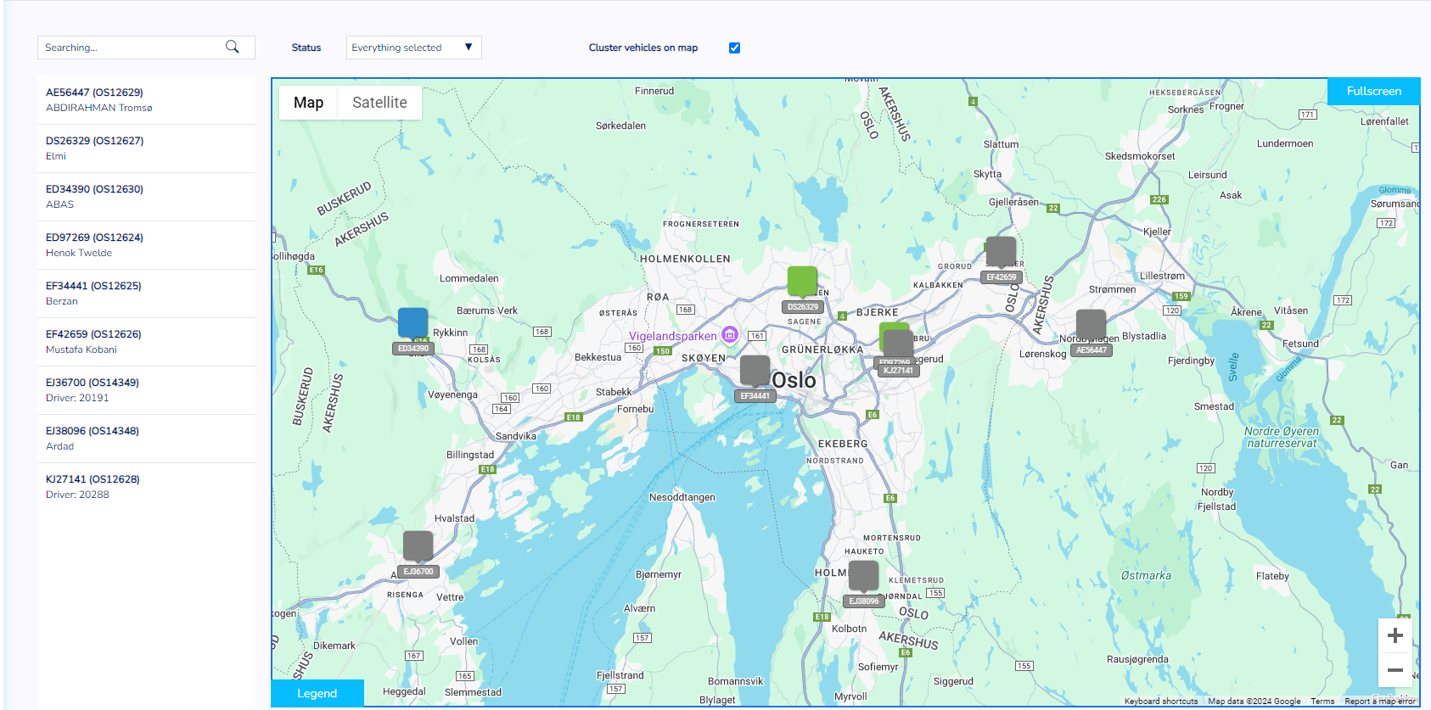
Each vehicle has a colour, this colour indicates the status of the vehicle. There are the following:
It's also possible to use the 'Status' filter. This is located above the map with the live overview. This filter allows you to filter the live overview according to the statuses mentioned above. For example, would you like to see all your available vehicles? Select 'Available' in the status filter and the maps will show all vehicles with that status.
Want to see more information about a particular vehicle? Click on the vehicle on the map and you'll see information such as its status, last known position and when it started its shift.

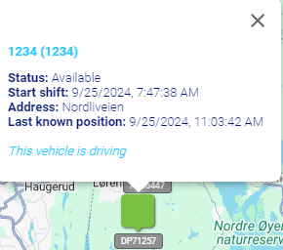

Drivers
Next up is the Driver page. If you have a Cabman MDT installed in your car, you will need to add your driver information to Cabman Data. You can do this on the Driver page. This is necessary because if the driver isn't added to Cabman Data they won't be able to start a shift. Each driver must have their own 'Driver Number' and a personal 'Pin' code. This number and code must be added to Cabman Data in order to start a shift. Once you have added the driver, you can also view the vehicle and driver information in Cabman Data.
How to add a new driver
To add a new driver, click on the 'New' button on the Driver page. This will take you to a new screen where you can enter details such as: name, driver number, pin code, phone number, email address and language. It's also possible to add a photo in this screen.
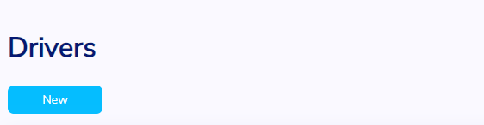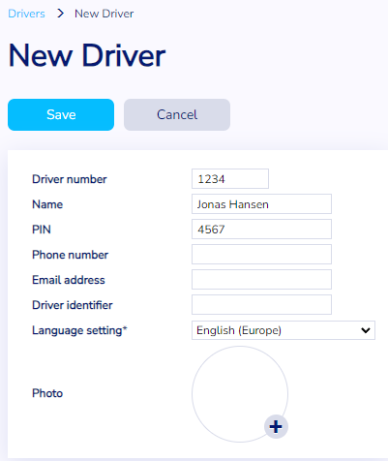

4. Vehicles
The third tab in Cabman Data is Vehicles. In this section of Cabman Data you can see all your vehicles. In order for them to appear automatically in this overview, you must
- Have a Cabman MDT installed in the vehicle
- Have registered your drivers
- Have started at least one shift on the Cabman MDT in the vehicle.
There are several ways to filter this overview of your vehicles. You can filter by:
- Licence plate
- Vehicle Number
- Software Version
- Tariff
- Mypos (TID)
- External Code
Making exports
Want to export your vehicle data? It's easy. Just press the Excel button on the right hand side of the screen. Cabman Data generates and downloads a report with all the data from the vehicle overview. Quick and easy!
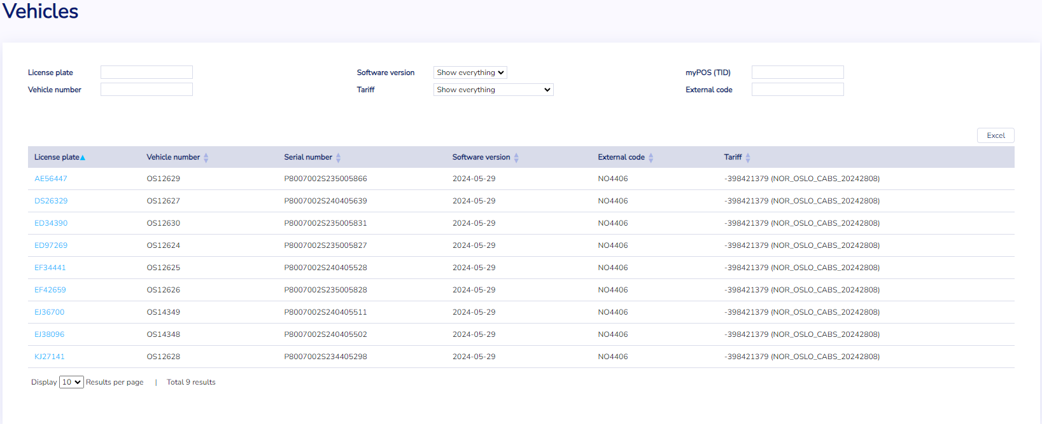

More information
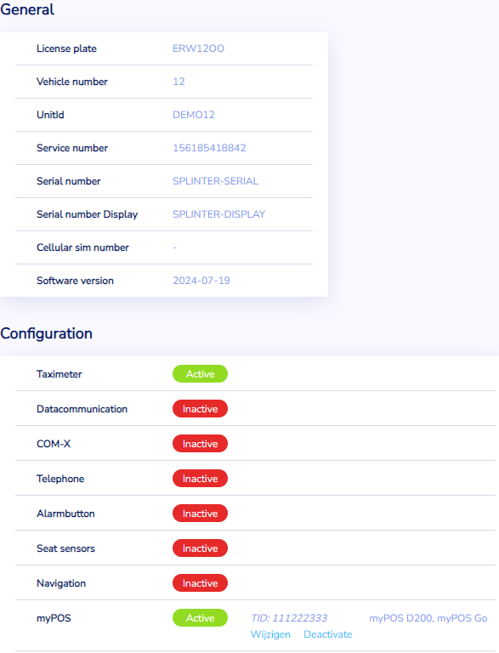
Want to see more information about a particular vehicle? Just click on the licence plate in the licence plate column. This is the column on the left. If you click on it, you'll see more detailed vehicle information about the selected plate, as shown in the image below.

5. Shifts
The fourth and final page is the 'Shifts' page. This page shows all the shifts your drivers have done in your vehicles over the last sixty days. The overview can be filtered:
- ‘Shifts from’: a period of time can be selected.
- ‘Driver’: Specific driver(s).
- ‘Vehicle’: Vehicles can be selected for this period and/or driver.
- ‘Shift Number’: A specific shift number can be selected.

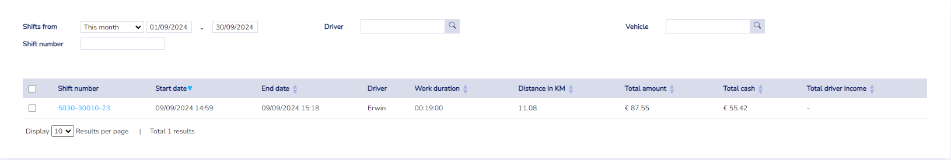
Driver income
Do you want to know how much a driver has earned during a specific period or shift? That’s also possible. Select the shifts for which you want to know the income and press the "Calculate Driver Income" button. Cabman Data will provide you with a summary of the income for the selected shifts.
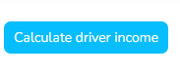
Reports
As well as showing all the shifts for the last sixty days and the driver's earnings, it's also possible to view various reports. There are five report types to choose from. These are the following and will be explained in the next sections:
- The totals for selected driver(s) report
- The totals for selected vehicle(s) report
- The shift summary report
- The payment summary report

5.1 Totals for selected Driver(s)
In the ‘Shifts’ section it’s possible to generate different reports. The first one is the totals for selected drivers. This summarizes all (selected) shifts per driver
Columns shown:
- Driver
- Driver Identifier
- Work duration (end shifttime – start shifttime)
- Distance in KM
- Cash
- Not Paid
- Tip
- Discount
- Amount (Netto)
- Driver Income (Netto – Toll – Notpaid)
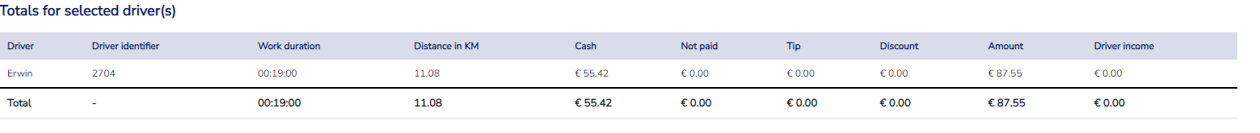

5.2 Totals for selected Vehicle(s)
Summarizes all (selected) shifts per vehicle
Columns shown:
- Vehicle (licenseplate)
- External Code
- Work duration (for every shift “selected” sum of: end shifttime – start shifttime)
- Distance in KM (for every shift “selected” sum of: end shiftodo – start shiftodo)
- Cash
- Not Paid
- Tip
- Discount
- Amount (Netto)
- Driver Income (Netto – Toll – Notpaid)

5.3 Shift summary
The shift summary summarises all (selected) shifts per activity. In this report you’ll find the following columns:
- (Group)Type (productive, unproductive, private, outside shift)
- KM (for every shift “selected” sum of: end shift odo – start shift odo) for that group type
- Percentage of total KM’s.
- Activity name
- KM (for every shift “selected” sum of: end shiftodo – start shiftodo) for that activitytype
- Percentage of total KM’s for that activity type
- Hours (for every shift “selected” sum of: end shift time – start shift time) for that activity type
- Percentage of total hours for that activity type
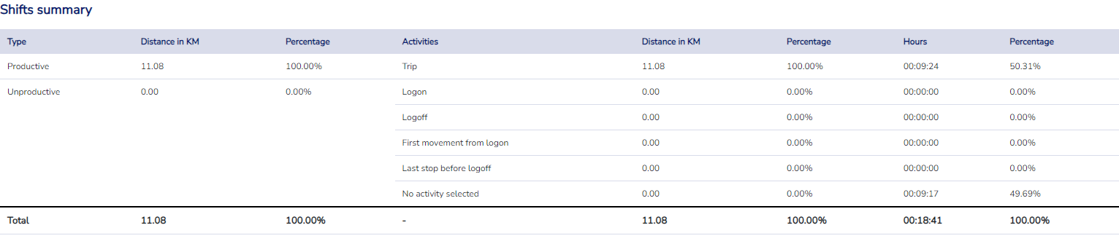

5.4 Payment summary
The payment summary summarizes all (selected) shifts per payment type. The following columns are displayed in this report:
- Type
- Count (of Payments, not trips)
- Gross sum
- Percentage
- Tip
- Discount
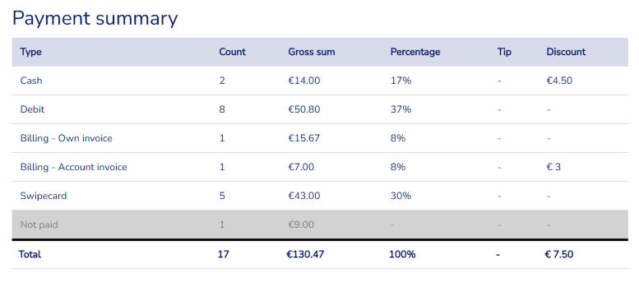

5.5 VAT Summary
The last report is the VAT Summary. As the name suggests, it summarises all (selected) layers per VAT percentage. It displays the following columns:
- VAT
- Gross
- Netto
- VAT Amount
- Count (of Trips)
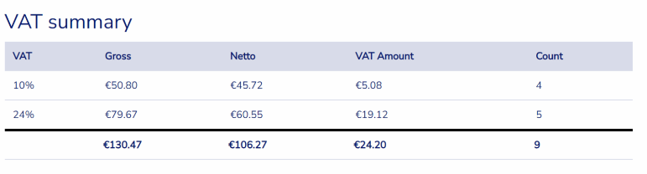

5.6 Export to PDF and Excel

All the different reports can be easily exported by pressing one of the buttons in the top right hand corner. Want a report in PDF format? Select Export PDF. Want to export to an Excel spreadsheet? Click on Export Excel.
